Most Popular Language in World-X

John Wensink

ITS410 Database Management

Colorado State University-Global Campus

Dr. Dan Morrill

December 8, 2019

Most Popular Language in World-X

This week our assignment was to list countries and their capitals where less than 30% of the population speaks English. We needed to apply our skills with querying a single database, as well as adding to those skills in order to use multiple join statements to present meaningful results (Boronczyk, 2015). The data we needed was located across multiple tables including ‘country’, ‘city’, and countrylanguage. The query can be broken up into three main parts. The first part is a simple select statement where we chose which columns would be relevant to our query. Executing the select statement by itself returns an error, as there is no city.name column in the ‘country’ table. We needed to add an inner join statement in order to use columns from the ‘city’ table based on the city.id. Meaningful results require that we reference the country.capital’s name with the city.id in order to retrieve the city’s name as opposed to its numeric city.id. This assignment necessitated another join statement, with a where clause specifying the condition that only countries where language = English and the percentage of English speakers was less than 30%. The ‘and’ modifier was used for this task, indicating there were two criteria that needed to be met, country.langage = ‘English’ and countrylanguage.percentage was less than thirty (W3resource, 2019). For easy readability, the result columns were renamed ‘Country’ and ‘Capital.’ The syntax for this query was a process of trial and error. There were many unsuccessful attempts at displaying the data in a useful way. One of the most difficult parts was getting the capital cities to return as city names rather than city ids. The inner join city on country.capital = city.id was where I kept getting tripped up and I must thank a guest user on (Pastebin, 2019) for showing me the correct syntax. The complete code is six lines long. Simple and eloquent:

SELECT country.name AS Country, city.name AS Capital

FROM country

INNER JOIN city on country.capital = city.id

INNER JOIN countrylanguage on country.code = countrylanguage.countrycode

WHERE countrylanguage.language = 'English'

AND countrylanguage.percentage < 30

This query produces the desired result of countries and their capitals where English is spoken by less than 30% of the population. 46 rows were returned:

Aruba Oranjestad

Anguilla The Valley

Netherlands Antilles Willemstad

American Samoa Fagatogo

Antigua and Barbuda Saint John´s

Bahrain al-Manama

Barbados Bridgetown

Brunei Bandar Seri Begawan

Cocos (Keeling) Islands West Island

Cook Islands Avarua

Christmas Island Flying Fish Cove

Cayman Islands George Town

Denmark København

Falkland Islands Stanley

Hong Kong Victoria

Iceland Reykjavík

Japan Tokyo

Saint Kitts and Nevis Basseterre

Kuwait Kuwait

Saint Lucia Castries

Lesotho Maseru

Macao Macao

Monaco Monaco-Ville

Maldives Male

Marshall Islands Dalap-Uliga-Darrit

Malta Valletta

Northern Mariana Islands Garapan

Montserrat Plymouth

Malaysia Kuala Lumpur

Norfolk Island Kingston

Niue Alofi

Norway Oslo

Nauru Yaren

Palau Koror

Saint Helena Jamestown

Seychelles Victoria

Turks and Caicos Islands Cockburn Town

Tokelau Fakaofo

Tonga Nuku´alofa

Tuvalu Funafuti

Saint Vincent and the Grenadines Kingstown

Virgin Islands, British Road Town

Vanuatu Port-Vila

Samoa Apia

South Africa Pretoria

Zimbabwe Harare

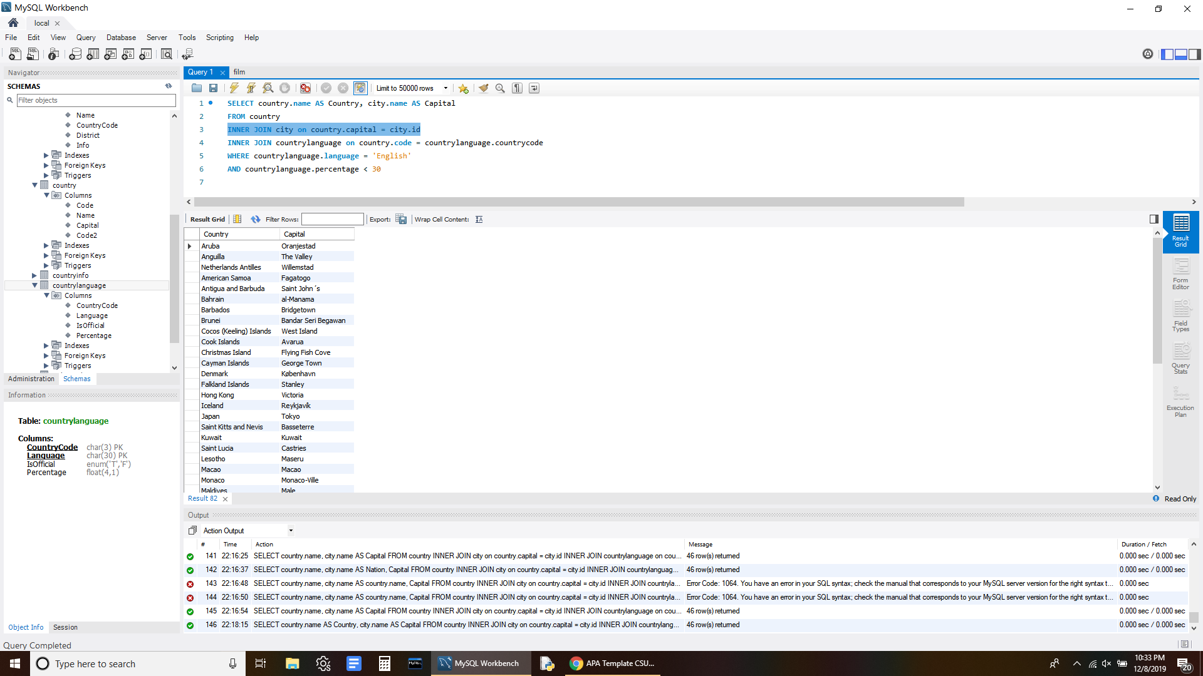

References

Boronczyk, T. (2015). Jump Start MySQL. Retrieved December 8, 2019 from <https://bookshelf.vitalsource.com/#/books/9781457192838/cfi/69!/4/4@0.00:16.1>

Pastebin. (2019, November 26). 1. SELECT COUNT(Name) FROM Country CROSS JOIN CountryLanguage; 2. 1. SELE. Retrieved December 8, 2019, from <https://pastebin.com/aA5uGJ1e>.

W3resource. (2019, November 9). SQL INNER JOIN. Retrieved December 8, 2019, from <https://www.w3resource.com/sql/joins/perform-an-inner-join.php>.